Assignment No: 1

Name: Muhammad Mubbashir Khan

Class: ME-15 SEC(B)

Reg no: 465077

Task No.1

Factorial of 6

#include <iostream>

using namespace std;

// A function to calculate the factorial of a given number

int factorial(int n) {

// Base case: if n is 0 or 1, return 1

if (n == 0 || n == 1) {

return 1;

}

// Recursive case: return n times the factorial of n-1

else {

return n \* factorial(n - 1);

}

}

// A main function to test the factorial function

int main() {

// Declare a variable to store the input number

int num =6;

// Call the factorial function and print the result

cout << "The factorial of " << num << " is " << factorial(num) << endl;

// Return 0 to indicate successful execution

return 0;

}

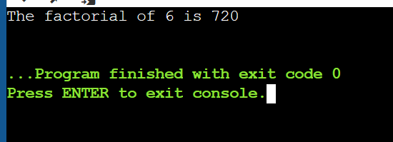

Task No.2

Write a C++ program to calculate distance between two points. The values of coordinates should be input by user

#include <iostream>

using namespace std;

int main()

{

// Declare FOUR variables to store the values of A,B,C,D

int A,B,C, D;

// Prompt the user to enter the values of A,B,C and D

cout << "Enter the value of A: ";

cin >> A;

cout << "Enter the value of B: ";

cin >> B;

cout << "Enter the value of C: ";

cin >> C;

cout << "Enter the value of D: ";

cin >> D;

// Calculate the result using the formula A^2 - B^2

int result = (B-A)\*(B-A)

+

(D-C)\*(D-C);

// Display the result to the user

cout << "The Distance between points is: " << result << endl;

return 0;

}

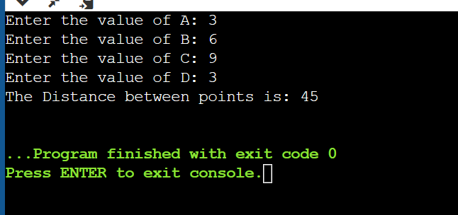

Task No. 3

Write a code in C++ to take length from user in centimeter and convert it into meter and kilometer.

#include <iostream>

using namespace std;

int main()

{

// Declare variable to store the value of Lcm

float Lcm;

// Prompt the user to enter the value of Lcm

cout << "Enter the value of Lcm: ";

cin >> Lcm;

// Calculate the result using the formula Lcm/100

float Lm = Lcm/100;

// Display the result to the user

cout << "Lenght in meter: " << Lm << endl;

// calculate the result using the formula Lkm/100000

float Lkm = Lcm/100000;

// Display the result to the user

cout << "Lenght in km: " << Lkm << endl;

return 0;

}

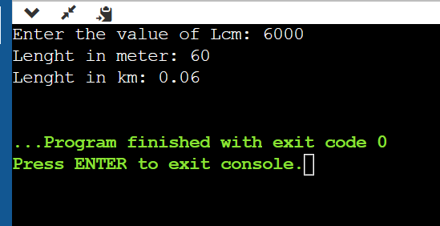

Task No. 4

Write a code in C++ that takes values of a and b from the user and displays result of polynomial 𝑎 2 + 2𝑎𝑏 + 𝑏 2

#include <iostream>

using namespace std;

int main()

{

// Declare variable to store the value of a and b

float a, b;

// Prompt the user to enter the value of a

cout << "Enter the value of a: ";

cin >> a;

// Prompt the user to enter the value of b

cout << "Enter the value of b: ";

cin >> b;

// Calculate the result using the formula

float result = (a\*a)+(b\*b)+2\*(a\*b);

// Display the result to the user

cout << "The result of polynomial is: " << result << endl;

return 0;

}

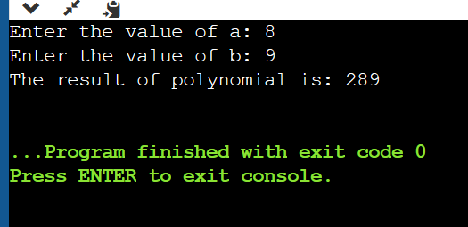

THE END